COIT20268

**RESPONSIVE WEB DESIGN**

**Term-1, 2020**

**Written Assessment**

**Lecturer/Tutor:**

**Tom Marotta**

**Prepared By:**

**Bishal Budhathoki**

**12116421**

Table of Contents

**Objective of this report: 4**

**Introduction: 4**

**Features of the website: 4**

In Page Header- 4

Domain name: 4

Logo: 4

Tag-Line: 4

Top Navigation: 4

Above the fold- 5

Image or Slider: 5

Videos: 5

Important Business Information: 6

Below the fold- 7

Quality Content: 7

Internal links: 8

Footer- 8

Navigation: 8

Social Media: 8

Business Hours: 8

Contact Information: 9

Inner pages- 9

About Us: 9

Contact form: 10

Captcha / Anti-spam Feature: 10

Privacy Policy, Disclaimer and Copyright: 11

Blog page: 11

**Positive & negative aspects of the website: 12**

Pros: 12

Cons: 16

**Reviews from friends: 20**

Review 1: 20

Review 2: 22

**Recommendation on how to improve: 23**

**Assertions relating to RWD design principles: 23**

**Chrome Device Simulator: 24**

Advantages of Chrome emulator: 24

Disadvantages of Chrome emulator: 24

**Similar tools: 24**

Responsive Web Design Tester Tool: 24

Webpagetest.org: 25

Responsive Inspector: 26

**Conclusion: 26**

**References: 26**

# Objective of this report:

This assessment / report focuses on critical evaluation of the website within the understanding of responsive web design and development principles. Complete evaluation is done to provide assertions for nominated website and reviewed in-depth. There are also some recommendations provided on critical analysis base for the website. Google Chrome emulator is used for testing the website.

# Introduction:

The Workshops Rail Museum located at North Street, North Ipswich, Queensland provides 15 humongous exhibition and tour of rails from the history with entertainment for kids aged 2-6 years. The website <https://theworkshops.qm.qld.gov.au/> provides information about the heritage and cultural knowledge that the Workshops Rail Museum provides. It is also aced at Australian and Queensland Tourism Awards for Heritage & Cultural tourism. It also sells products like books, gifts, homewares, t-shirt and more which also can be accessed from <https://www.shop.qm.qld.gov.au/> .

# Features of the website:

## **In Page Header-**

**Domain name:** It is easy to read and remember and also is similar with the business name. Domain name is theworkshops.qm.qld.gov.au

******Logo:** brand-name.svg is the icon used for logo with width and height of 1 px respectively is used. The icon is clear with gear representation with colour red and white along with the brand name on its right. Its position is at the top left corner of the webpage. There is navigational text to guide user to 5 different museums including The Workshops Rail Museum.

Figure 1: Logo of the website

**Tag-Line:** At the home page there is no tagline for the business although there is About Us page for the description of the company.

******Top Navigation:** There is navigation bar at the top to take user to various pages.

Figure 2: Top navigation to visit linked website

There is also a section below the navigation bar that changes while user hover around the navigation options providing information about what each option has to give.



Figure 3: Navigation Bar of the website

## **Above the fold-**

**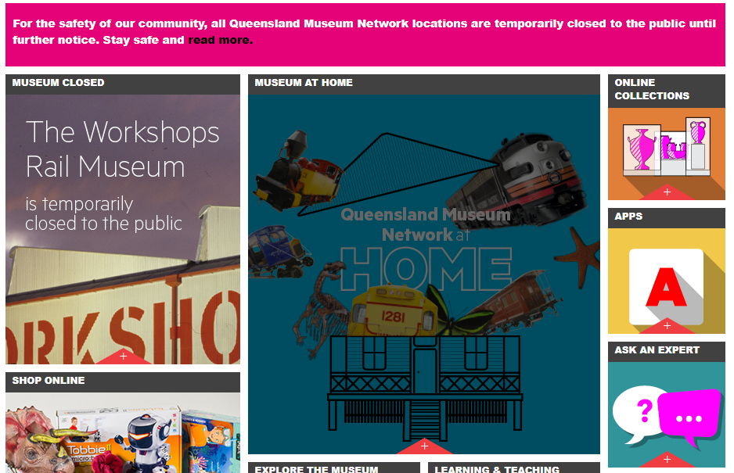****Image or Slider:** There are various images used of high quality and also slider in the Shop page.

Figure 4: Some of the images used

**Videos:** There are few sections in some of the pages where video is included like in Blog page.

 Figure 5: One of many videos used in the site

**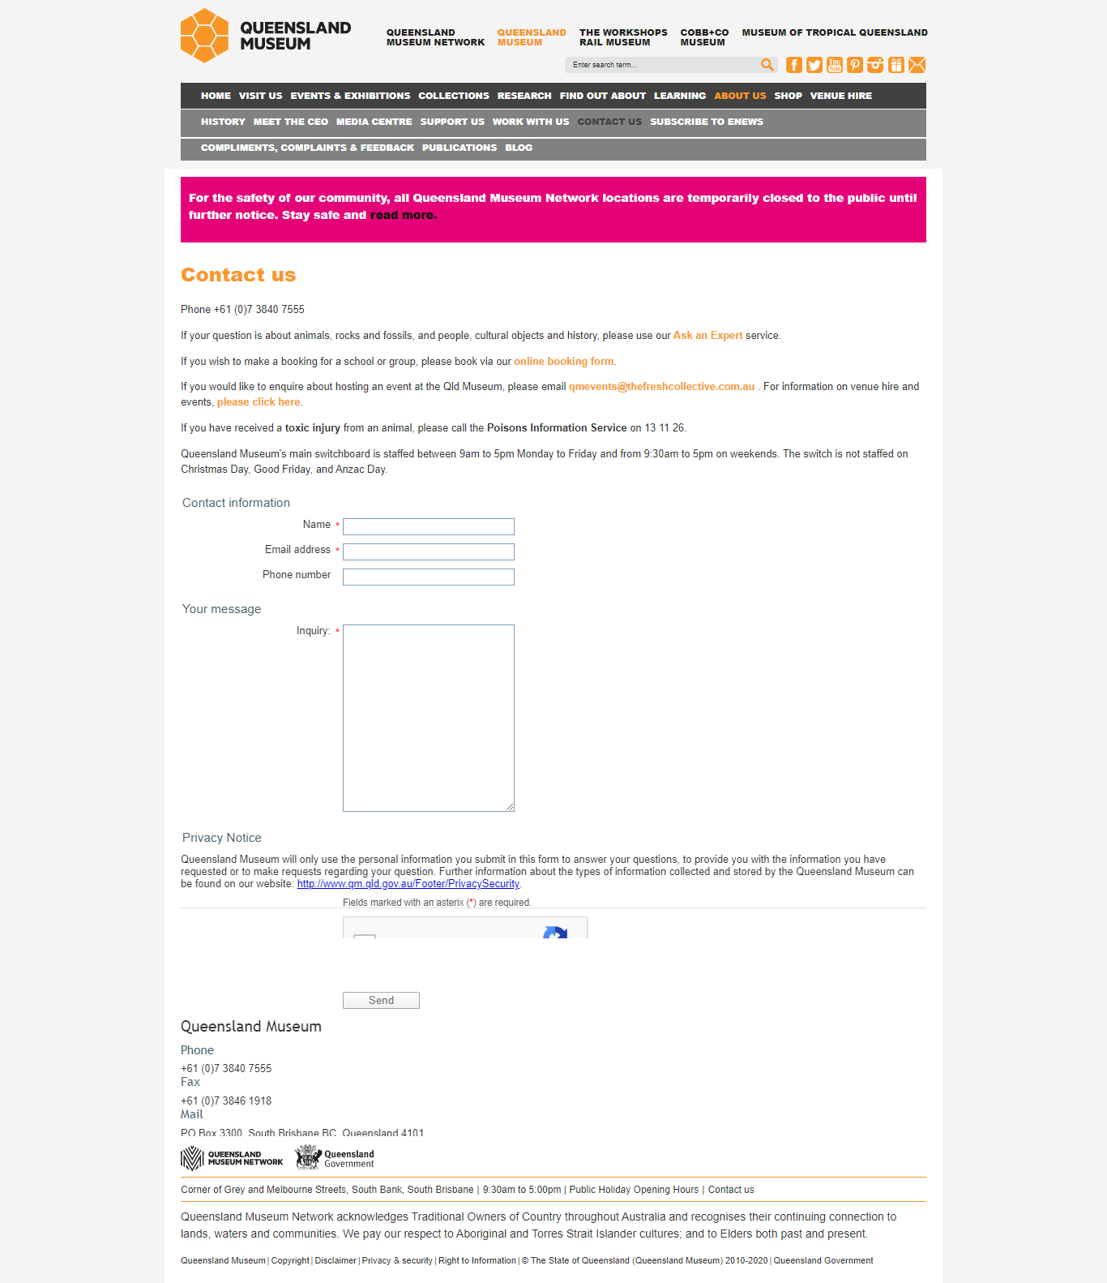****Important Business Information:** Details like location, about business, opening hours and prices, visitor map, facilities and more are provided to the visitor from the website itself.

Figure 6: Contact Us page

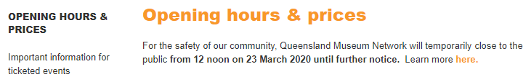

Figure 7: Opening hours and prices

## **Below the fold-**

**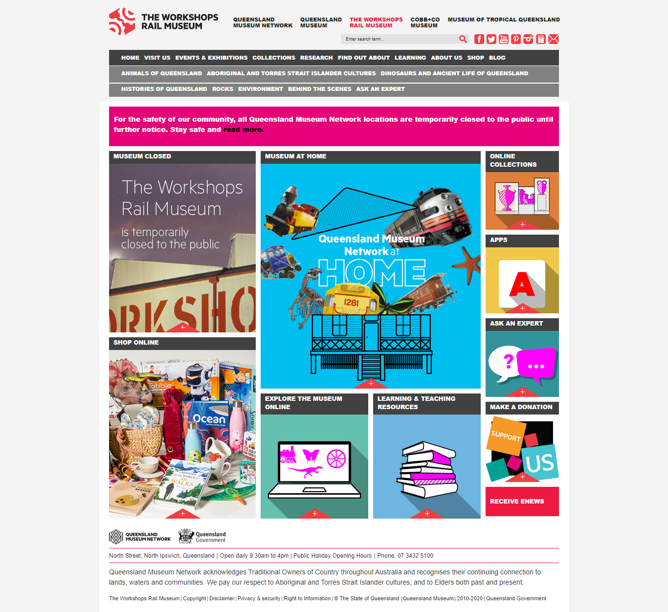****Quality Content:** There is an option to explore the museum online, learning and teaching resources, online collection and also an app to guide the visitor named Field Guide Apps, Frog ID, Tours. Games, Lost Creature Finder and many more.

Figure 8: Quality Contents of the site

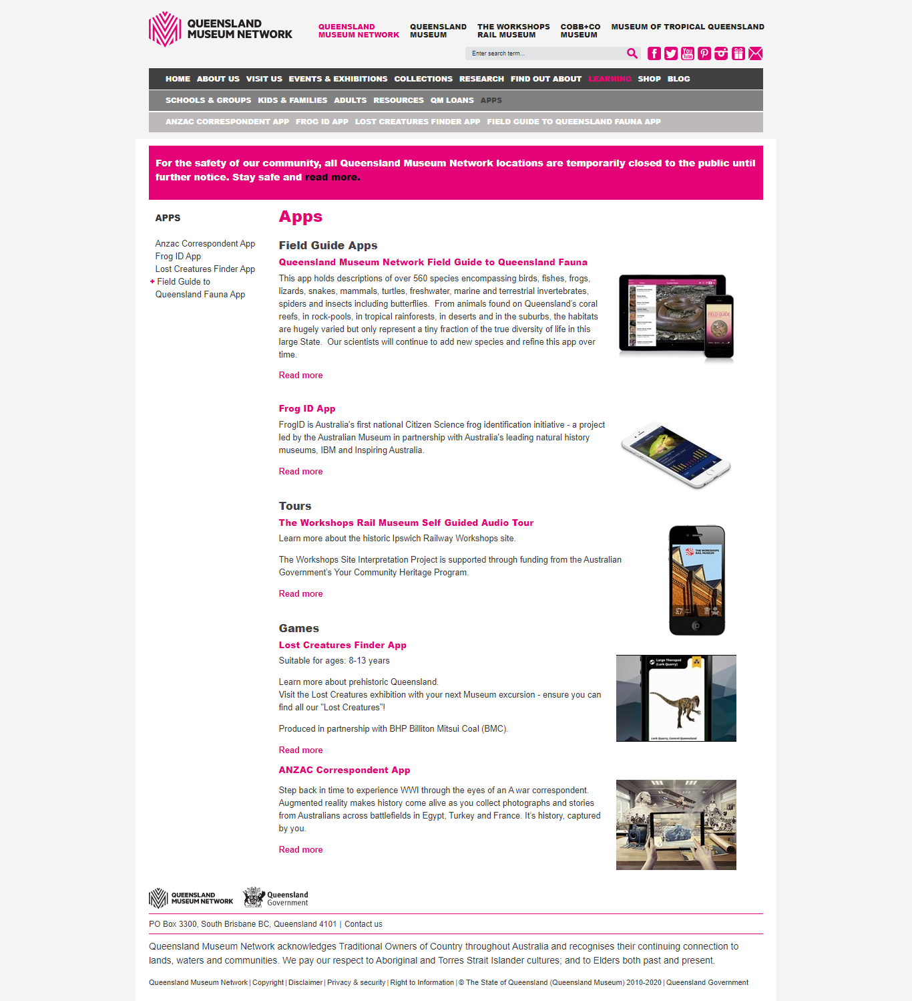 Figure 9: Mobile apps content page

**Internal links:** There are many references to various links to different pages/sites including from navigation bar, context body.

## **Footer-**

**Navigation:** Navigation bar provides secondary navigation to common pages even including some of the body section.

******Social Media:** There is a section at the top in home page and other section in various page possible, where link to their social sites including Facebook, twitter, YouTube, Pinterest, Instagram by using icons to represent them.

Figure 10: Social media links

**Business Hours:** Along with the location, to let visitors know when to visit opening hours detail is provided in visit us section in the navigation bar.



Figure 11: Business Hours

**Contact Information:** Address is provided in visit us and footer section. Footer section also contains phone number. Subscribe for update icon is provided at the top right with mail icon. There is separate Contact us page with inquiry form, fax, mail, email, and phone number.

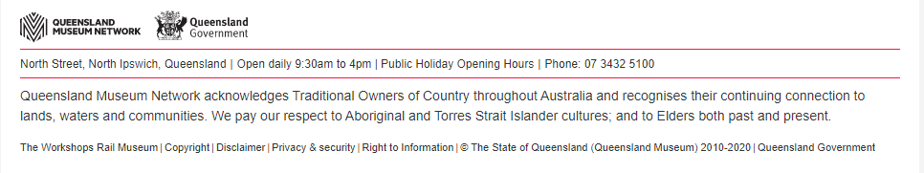

 (a)

(b)

Figure 12 (a) (b): Contact information that are available

## **Inner pages-**

**About Us:** Describes the business details, facts, history and what they have to offer. It includes history, news, vision plan and more.

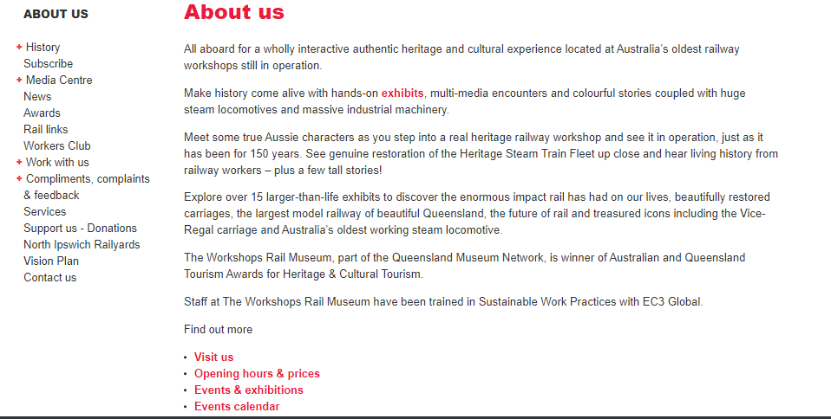

Figure 13: About us page

**Contact form:** Subscribe form, contact us form are the forms used. There is huge white space management issue in forms.



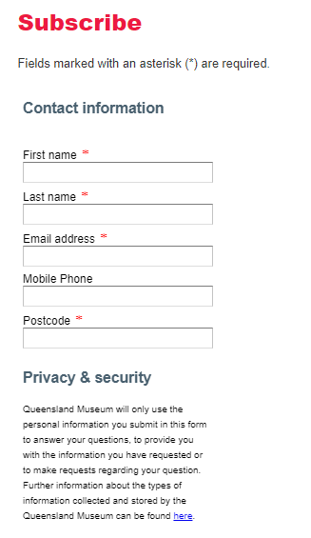

Figure 14: Contact us form and Subscribe form

**Captcha / Anti-spam Feature:** There is captcha to verify the user authenticity before submission of the contact us form.

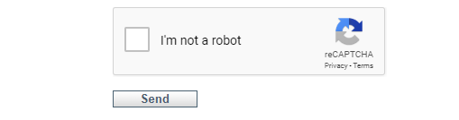 Figure 15: Captcha used in Contact us form

**Privacy Policy, Disclaimer and Copyright:** These pages let visitors when and where the utilization of the collected data is used, some of the disclaimer to put forward and Copyright that they own.

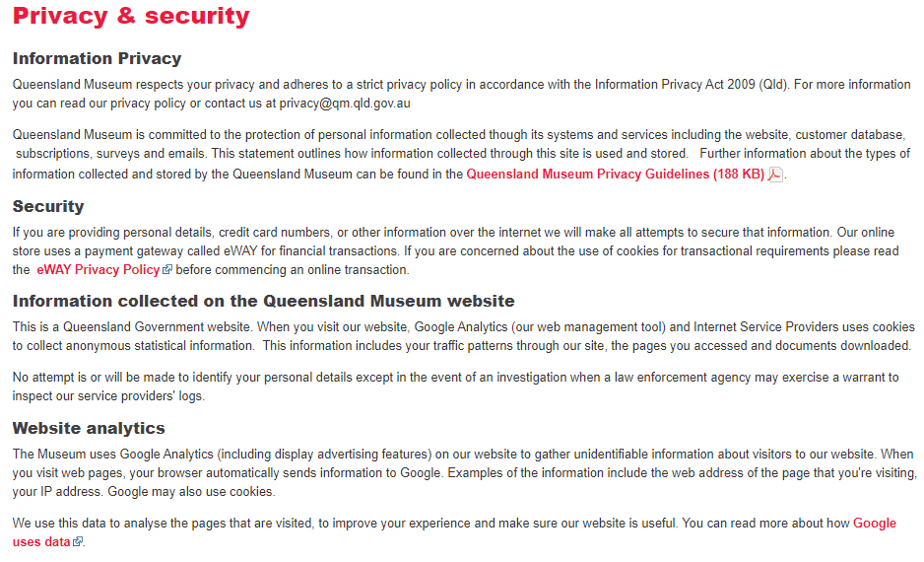

Figure 16: Privacy, Security information and more

**Blog page:** Any latest news, observations and important facts including advice are shared.

(Karr, 2018)

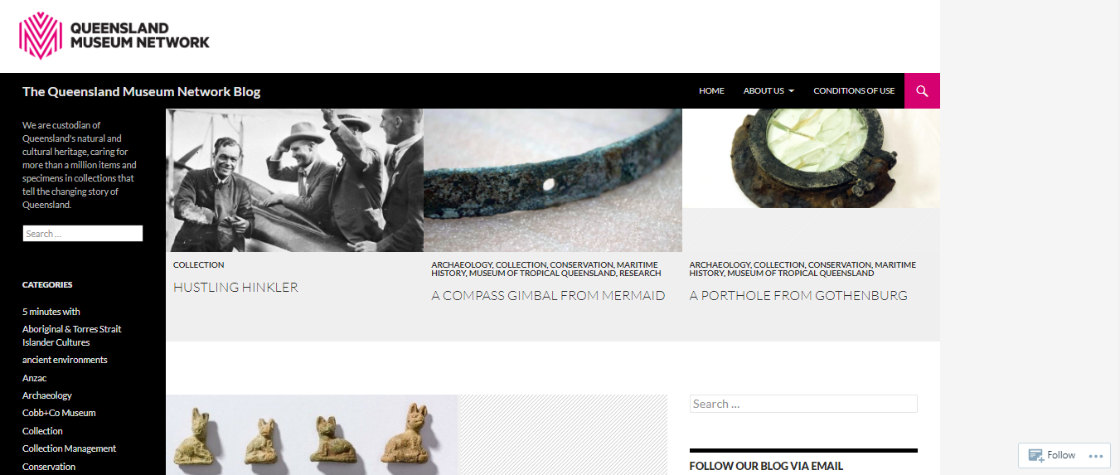

Figure 17: Blog page

# Positive & negative aspects of the website:

## **Pros:**

1. The website is responsive website so can support various devices and screen sizes.

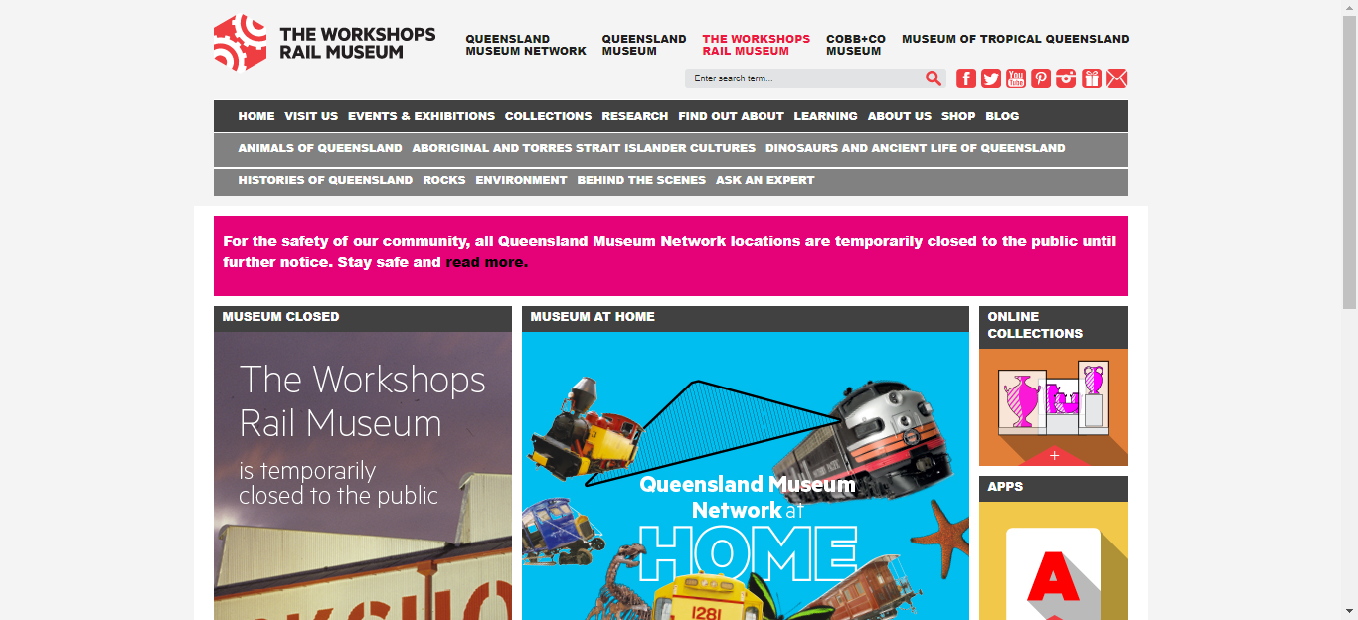

Figure 18: Desktop view

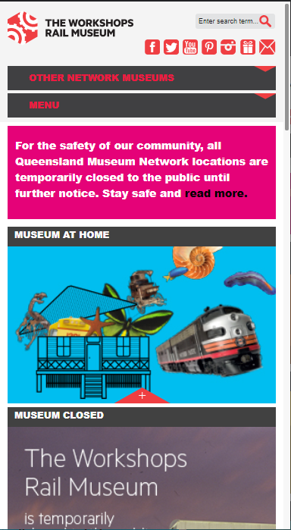 Figure 19: Mobile view from LG G5 portrait mode



Figure 20: Landscape View in LG G5

1. Every content is divided in sections and are well put together with use of high-quality images, slider and videos.

Figure 18: Contents divided into sections

1. The use of textual navigation bar makes it easier for visitors navigate through out the pages easier.



(a)



(b)

Figure 19 (a) (b): Textual navigation bar

1. Use of search bar to look for items, terms, features or pages works great.

Figure 20: Search bar

1. Shop along with the online payments integrated works great.

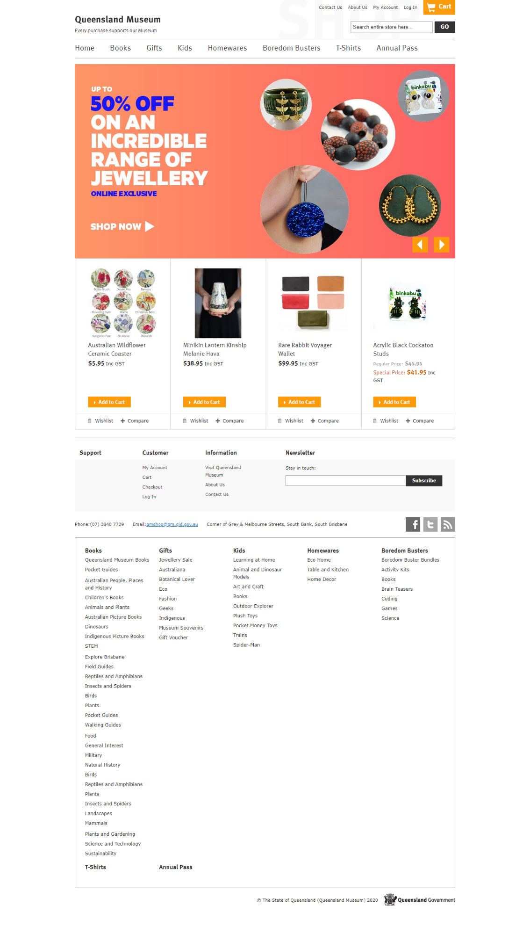

Figure 21: Shop site

## **Cons:**

1. The website has a huge white space in both left and right side of the screen.



 (a)

(b)



(C)

Figure 22 (a) (b) (c): Both sides contain huge white spaces in homepage, even in subscribe form, contact us form and blog page

1. 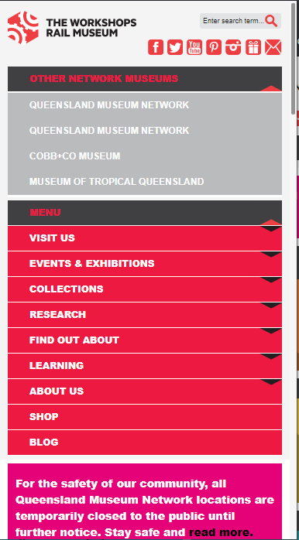Navigation bar gets compressed to single dropdown menu and sub menu is lost in this context when screen size is lower like 320 * 480 screen size.

Figure 23: Navigation bar in mobile device

1. While using search bar, entered text overrides search bar highlight text and both texts gets visible. It makes hard to understand the entered text.

Figure 24: Search bar bug

1. 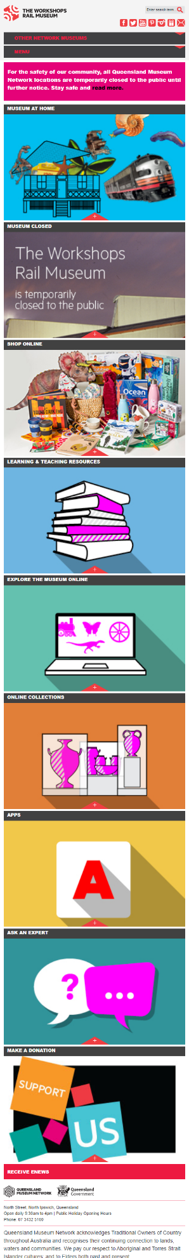When screen size is reduced, blocks of images takes over, features get compromised.

Figure 25: Block of images when resized to smaller screen

1. 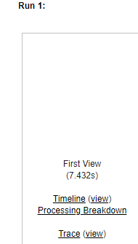Takes a lot of time to load.

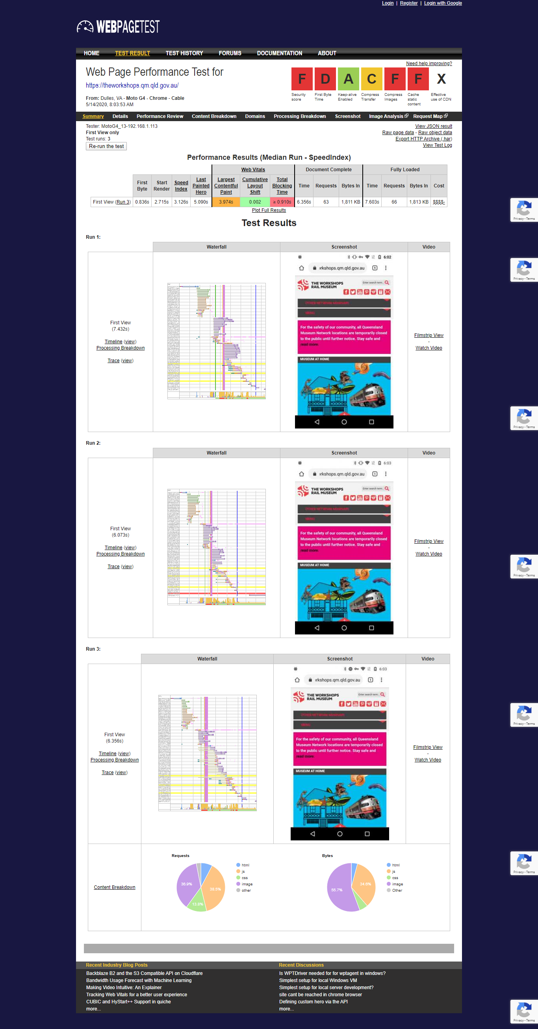 Figure 26: Time taken to load a single home page is 7.432 second

Figure 27: Test result with performance output

# Reviews from friends:

## **Review 1:**

I have chosen my friend Biplove who is also student from ECU and is of age 24. He has 2 years of experience as web developer. From the design and responsiveness factors, he finds the web pages look clear and well managed but responsiveness is not according to the design principles. He tests the site from chrome emulator. His observation is as follow:

1. 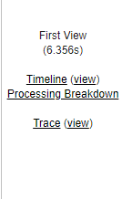All pages are not responsive as per provided standard.

Figure 28: Time to load result from webpagetest.org

1. Some pages work great with all screen size, some do not work fine.



Figure 29: Right side got huge white space and whole page does not extend to right in full

1. Footer is considerably large as per the standards and in small screen size it almost takes up a whole screen.

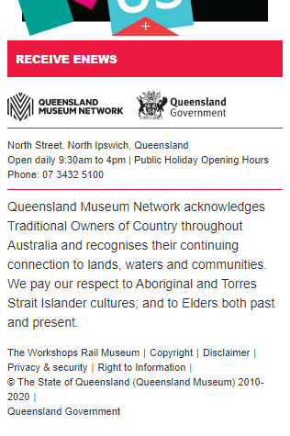 Figure 30: Huge footer specially for smaller screen

1. Colour scheme is good for the sites.

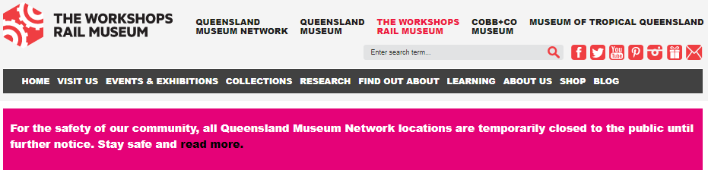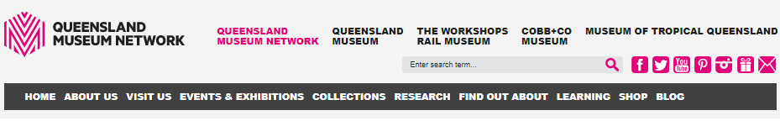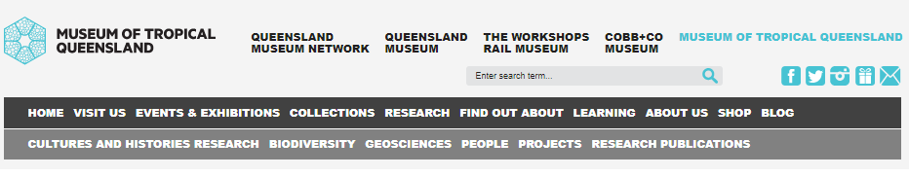

Figure 31: Colour Scheme around various pages

1. Search option works great but improvements is necessary.

## **Review 2:**

Secondly, I asked my wife who is a nurse and 22 years old. She was not able to find much of the issue using the chrome emulator. Her analysis was:

1. There are many pages and one home page can bring to another connected homepage of another website linked.



Figure 32: Many external pages with separate home page

1. Search works great, text issue found after loading the searched text.
2. Margins are high on left and right of the screen in most pages.
3. Due to large number of pages and various options some time leading to same page made her loose interest or felt lost.

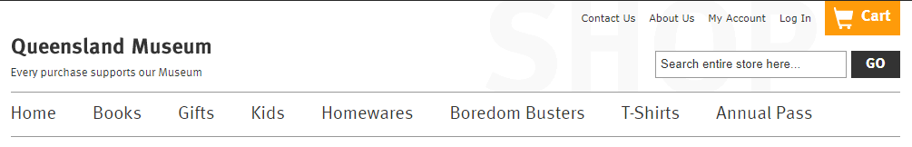

Figure 33: Pages that got no links to the home page of The Workshop Rail Museum

My views totally agree with their views as I checked the site using the Chrome emulator and checked all possible aspects as a designer, developer or normal user. Hence, I agree with their points.

# Recommendation on how to improve:

1. Content of the website should be considered for the huge screen too like desktop. So, the use of text and images would help reduce those white spaces on both sides of the screen.
2. Use of text along with images would greatly reduce the block like look from the web pages when reduced for smaller screens.
3. Use of less images or low-resolution images or different format images would highly decrease the reload time.
4. Use of text hint in CSS for search bar could remove the override of input text and supposedly hint text.
5. Navigation bar can have cascaded dropdown menu so that navigation bar would not get compromised in small display.
6. Use of hamburger like menu for header text above navigation bar once the screen gets reduced from desktop screen to any smaller screen would make content displayed more evenly and minimal or use of breakpoints would also help.

# Assertions relating to RWD design principles:

Assertions related to responsive web design principles are:

Responsive design takes consideration of mobile devices, tablets and laptops. So, the website is to able to access in RWD. Multiple version of same design for multiple devices is not a necessity for RWD. Responsive design principle is focused towards the design of the website as of other approaches. To design a responsive website, one must follow the stated principles:

1. **Responsive media:** The images and video should be scalable with resolution of various devices.
2. **Layout breakpoints:** With use of media in CSS, modification of physical layout at various breakpoint of website design can be done.
3. **Remove contents not required:** Contents that are not important or not required should be removed from the website and take care of important part as sometime not required content can take up lots of space in smaller display.
4. **Responsive navigation structure:** Navigation structure and system should be responsive enough for both smaller and bigger screen.
5. **Fluid grid built:** If a website is designed / built on fluid grid, it works on percentage basis rather than pixels.

Using these principles, responsive website can be designed providing better readability to the website visitors and can be navigated while on slower network connection.

(Ruluks, 2014)

# Chrome Device Simulator:

Testing of responsive web design (RWD) or mobile pages by detecting specific user agents can be done using Chrome device simulator. To test mobile design or RWD, chrome has a function for designers and developers to test in various mobile / tablets / iPhone or iPad.

It did test every pages of The Workshop Rail Museum website on desktop, mobile devices functionally. It found no issues while changing from portrait to landscape mode and vice-versa and supported more than two devices.

Advantages and disadvantages of using this tool are as follow:

## **Advantages of Chrome emulator:**

1. Can test and find functionality of websites designed as responsive site.
2. Emulates the devices for testing purposes.
3. Helps rectify bugs that might occur on HTTPS web-pages.
4. Captures full screenshots of the webpage.
5. Can test every resolution of screen in a matter of a click of a button.
6. Tests even partially build website on any device of any resolution.

(Mobile Device Emulator and Simulator vs. Real Devices, 2016)

## **Disadvantages of Chrome emulator:**

1. Results can be misleading after testing on emulator and then on real device.
2. If one wants the behaviour of GPU and CPU on emulator, it is not obtainable.
3. It does not check for Internet explorer. Hence, CSS rules are limited.
4. Hardware is not measured.

(Mobile Device Emulator and Simulator vs. Real Devices, 2016)

# Similar tools:

Some of the simulation tools are as follow:

## **Responsive Web Design Tester Tool:**

It tests mobile web pages on emulated mobile devices and defines size and browser of mobile device. It emulates responsive web design faster with similar dimension as it is intended to on mobile devices and utilise required user-agent but lacks rendering of webpages as mobile device.

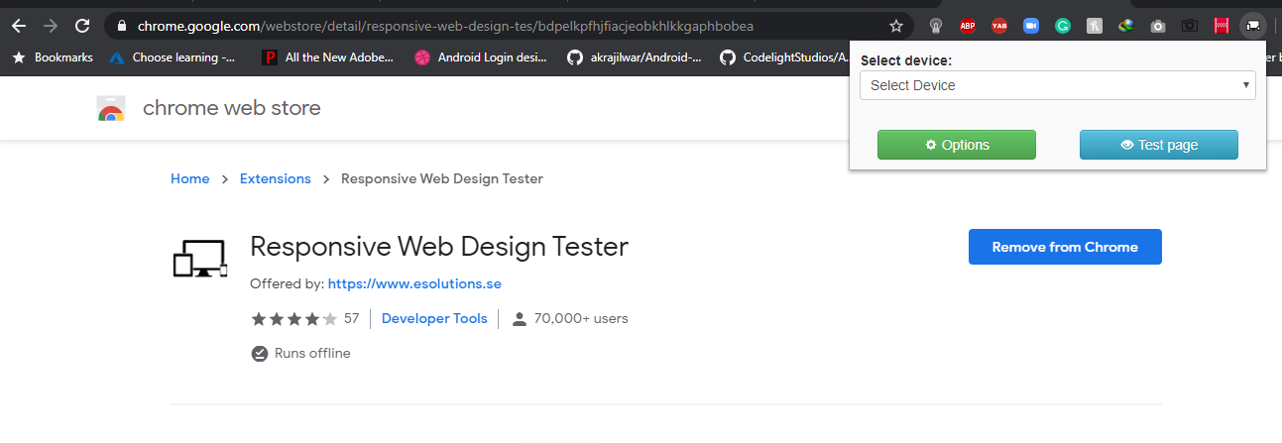

Figure 34: Responsive Web Design Tester Tool

## **Webpagetest.org:**

Here one can do speed test of website form various locations from the globe with real browsers including Internet Explorer which most lacks and with genuine connection speed. There are various advanced features for the developers and designers and provide results visually too like waterfall diagram, screenshots, videos, pie charts and many more including suggestions too.

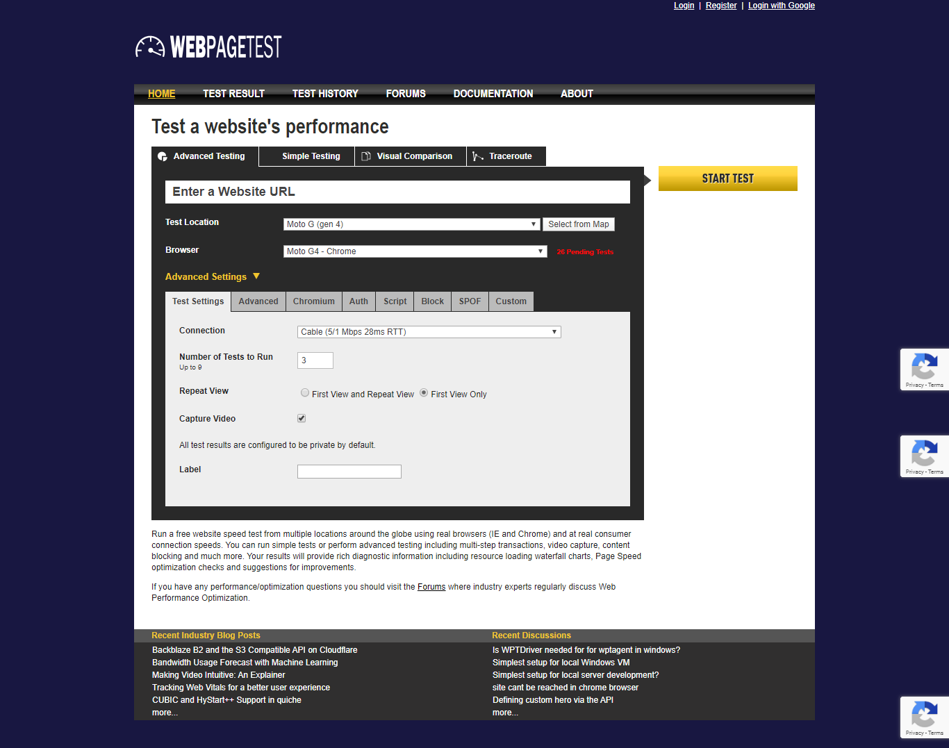

Figure 35: Webpagetest.org tool

## **Responsive Inspector:**

This is an extension for chrome browser that lets developers view queries of media for visited website. It can also take screenshots of whole page and is handy while designing layout.

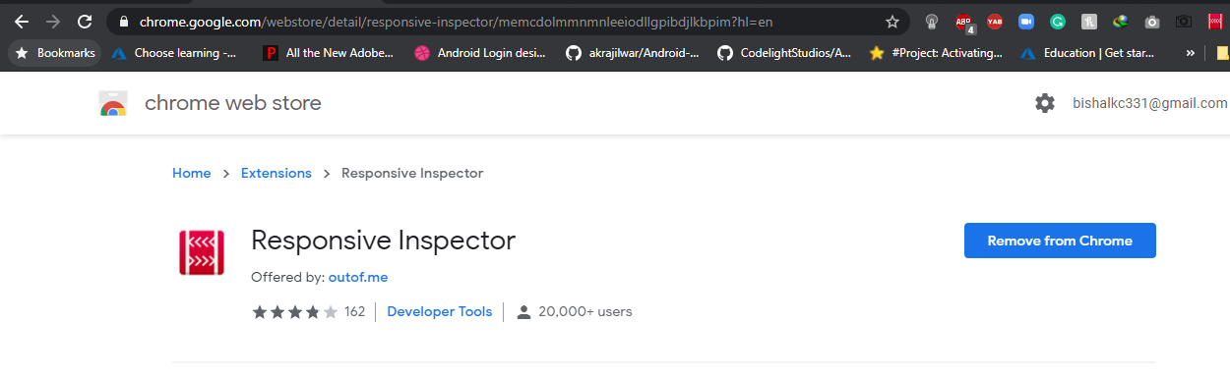

Figure 36: Responsive Inspector tool

(Chrome.google.com, 2016)

# Conclusion:

The Workshops Rail Museum is an Australian website is developed using HTML, CSS, JavaScript and medias like images, videos. It is supported by all possible devices aiming all possible target audiences except for new born to age 1. It is also available in Facebook, Instagram, Pinterest, Twitter, YouTube and email. Text and background colour complement each other and texts are readable.

All possible testing has been done in consideration with Responsive web design and its principles like:

* Able to find and elaborate main features of The Workshops Rail Museum website.
* Pros and cons of the website on usability and functionality aspects.
* Depending on the determined pros and cons, some improvements to make is also recommended like for search bar, white spaces.
* Chrome device simulator is analysed along with advantages and disadvantages of it and commented on other tools like Responsive Web Design, SEO Quake, responsive Inspector.

# References:

Chrome.google.com. (2016). *Mobile/Responsive Web Tester*. [online] Available at: <https://chrome.google.com/webstore/detail/responsive-web-design-tes/bdpelkpfhjfiacjeobkhlkkgaphbobea> [Accessed 14 May 2020].

Chrome.google.com. (2016). *Responsive Inspector*. [online] Available at: <https://chrome.google.com/webstore/detail/responsive-inspector/memcdolmmnmnleeiodllgpibdjlkbpim?hl=en> [Accessed 10 May 2020].

Webpagetest.org. (2020). *WEBPAGETEST*. [online] Available at: <https://www.webpagetest.org/> [Accessed 10 May 2020].

Karr, D. (2018). *Website Features Checklist: The 65 Ultimate Must-Haves for Your Site*. [online] Available at: <https://martech.zone/website-features-checklist/> [Accessed 14 May 2020].

Saucelabs.com. (2016). *Mobile Device Emulator and Simulator vs Real Device.* [online] Available at: <https://saucelabs.com/blog/mobile-device-emulator-and-simulator-vs-real-device> [Accessed 14 May 2020].